Adopted by the ACE general Assembly in October 2003

Copenhagen October 2003

Background paper

Prepared for the Task Force on Urban Issues (TFUI), PC1, ACE-CAE
Author: Henning Thomsen DAL-AA, Denmark

[This paper serves as a background paper for the policy recommendations paper.]

Governance & Urban Governance

Governance
The literature on governance is vast and furthermore the meanings implied by or attached to the notion of governance is extensive. The following thus serves only as a rudimentary introduction to the term itself and the meanings attached to it.

The European Commission, in its report on European governance from 2003, describes the notion of governance thus:

“European governance is about the principles and tools for decision-making within the context of the multiple layers of players and decision-makers in Europe […] The coexistence and intertwining of several governance levels clearly constitutes unprecedented challenges.”

In essence the Commission in the White Paper though chose to apply the notion ‘governance’ in a more or less self-evident manner of understanding. But subsequently the Commission also had to acknowledge, that the term does not have a unified, cross-cultural meaning, and thus that

“…the issues and approaches proposed in the White Paper were addressed [in the public consultation] according to the prism through which respondents understand the subject matter of European governance…”

Thus the Commission acknowledges that the understanding of governance may vary from country to country.

In an academic sense, governance covers a variety of positions. The principle evolution of the term here is seen in relation to the term ‘government’ and in a historic way, in relation to the break-down of classical forms of government and the evolution thus of more contemporary forms of government, implied by the notion of ‘governance’.

In short, government is understood as traditional, formal institutions in society ‘governing’ the collective actions. ‘Governance’ indicates new processes and new forms of organizing the collective actions of society. In addition governance is often used in connection with a particular period in the development of societies, commonly known as the post modern or late modern period, characterised as it is by globalisation, economic restructuring, technological advances and social and cultural differentiation.

Gerry Stoker (1998, p. 18) writes about governance:

“Its value is as an organizing framework. The value of the governance perspective rests in its capacity to provide a framework for understanding changing processes of governing. […] The governance perspective works if it helps us identify important questions, although it does claim to identify a number of useful answers as well. It provides a reference point which challenges many of the assumptions of traditional public administration.”

Stoker (1998, p. 18) outlines five central issues involved in governance:

“Governance refers to a set of institutions and actors that are drawn from but also beyond government. Governance identifies the blurring of boundaries and responsibilities for tackling social and economic issues. Governance identifies the power dependence involved in the relations between institutions involved in collective action. Governance is about autonomous self-governing networks of actors. Governance recognizes the capacity to get things done which does not rest on the power of government to command and use its authority. It sees government as able to use new tools and techniques to steer and guide.”

And finally, for our purposes, one final quote will suffice:

“By the term governance all actors involved in collective actions acknowledge that none of them have complete information, a full overview or even enough resources to tackle the problems of society by themselves.” (Sehested 2002, p. 5, my translation)

Thus the notion of governance implies an evolution in public decision making, that extends the sphere of possible actors to include both public and private actors, extends the sphere of acknowledged stakeholders, and broadly speaking implies the necessity for new forms of partnerships in public decision making. In particular the notion of governance influences the part of public decision making that have to do with cities and with the urban realm as such, hence the evolved notion of ‘urban governance’.

European governance
The promotion of new forms of governance was identified by President Romano Prodi as one of four strategic objectives of the current Commissions programme. Following this the European Commission on 25 July 2001 adopted a White Paper on European Governance, which has since been the subject of debate. A public consultation was launched, running up until 31 March 2002, allowing members of the public to submit their comments.

The background for committing the Commission to this particular strategic objective is formulated in the White Paper in the following manner:

“Today, political leaders throughout Europe are facing a real paradox. On the one hand, Europeans want them to find solutions to the major problems confronting our societies. On the other hand, people increasingly distrust institutions and politics or are simply not interested in them. […] Democratic institutions and the representatives of the people, at both national and European levels, can and must try to connect Europe with its citizens. This is the starting condition for more effective and relevant policies.”

And in the Report from the Commission on European Governance, published in 2003, the following conclusion is drawn:

“Promoting new forms of governance is by no means the sole responsibility of the European institutions, and even less so that of the Commission alone. It is the responsibility of all levels of public authority, private undertakings [my italics] and organised civil society because good governance – openness, participation, accountability, effectiveness and coherence – are what the public expects at the beginning of the 21st century.”

The relevance of the debate on governance for architecture and architects should be seen in this light. Even if the starting point for the discussion has been the citizens uncertainties regarding the credibility of actions taken by various levels of public bodies – legislative and executive – the answer to this particular problem calls also on sectors and levels and individuals in society, who do not themselves have legislative and executive powers, but are evidently affected by them on a permanent basis.

ACE and governance – policy targets and recommendations

“Good governance is much more than simply a rule book for regulating the behaviour of government. It is a cooperative effort for sustainable development, undertaken in concert by local government, civil society groups and the private business sector. It is entrepreneurship to achieve public goals. It is a creative answer to local needs, using local resources, creating organizations and institutions which coordinate a multitude of efforts integrating community organizations, private companies and governmental actors.”

Urban Future 21 – A Global Agenda for Twenty-first Century Cities, Peter Hall and Ulrich Pfeiffer

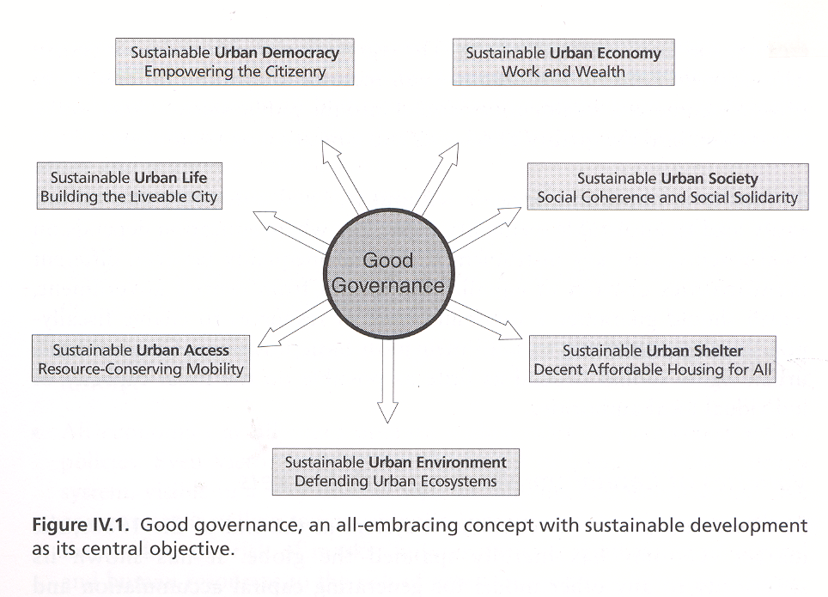
Figure IV.1. in Urban Future 21 – A Global Agenda for Twenty-first Century Cities, Peter Hall and Ulrich Pfeiffer

The impact of architecture on people’s lives is obvious, the role the profession of architecture has to play on the other hand is not self evident in the public’s mind. An ever expanding world, infringement on the profession of architecture by ‘sister’ professions, economic restraints, etc., all challenge the profession and call for the adoption of forward-looking policies.

Hence the architectural profession requires policies that consolidate and situate the profession in the public’s mind.

And the architectural profession desires policies that harbour and accommodate the public’s concern with the built environment.

Architecture makes a difference. ACE policies must too.

It should be observed that in and of itself governance is not an architectural ‘issue’. The scope of the term and its implications covers all of society. On the other hand governance is not without implications and opportunities for the profession of architecture. Thus the task at hand when reflecting on these implications and opportunities is to turn governance into an architectural issue.

Therefore the suggestion here is, to let sustainable urban development and the quality of life in the built environment (truly architectural issues) become the core around which ACE policies regarding governance are constructed and expressed.

The Task Force on Urban Issues therefore calls on the General Assembly of ACE to supplement the existing policies on governance and urban governance with the following new policy points:

- Actively promote the adoption of partnership approaches to urban planning and urban development to secure a sense of shared responsibility for sustainable urban development and the quality of life in the built environment.
The profession of architecture should work actively to overcome potential estrangement from society by adopting an open-minded and inviting stance to collaboration.

- Actively promote the development and adoption of good urban planning principles that have at their heart the publics concern with sustainable urban development and the quality of life in the built environment.
The profession of architecture should partake actively in the debate and development of good urban planning principles, aspiring on all levels to balance professional and societal concerns.

- Actively promote both technical and non-technical targets for sustainable urban development and the quality of life in the built environment.
The profession of architecture should acknowledge that it has a role to play both in the development of technical solutions to the challenges raised in the built environment as well as when it comes to changing attitudes.

- Actively promote and facilitate the adoption of serious policy oriented curricula in architectural education, in order to prepare new architects for the very changed role they have to play in society.
The profession of architecture should continue to acknowledge its role in the development of a better architectural education by making its knowledge of the challenges and potentials implicit in the complexities of the current world manifest in the educational debate.

- Actively promote and pursue commitment to the development of good governance principles on European, regional, and local levels.
The profession of architecture should take advantage of its multi-level presence to market its productive input to the development of good governance principles, sustainable urban development and the quality of life in the built environment.

Literature
Byrne, David: Understanding the Urban. Palgrave, Hampshire, 2001.
Commission of the European Communities – European Governance A White Paper, July 2001, http://europa.eu.int/comm/governance/white_paper/index_en.htm
Commission of the European Communities – Report from the Commission on European Governance, 2003 http://europa.eu.int/comm/governance/docs/comm_rapport_en.pdf
Eurocities – Executive Summary of the Vienna Conference, July 2002, http://eurocities.poptel.org.uk/viewPage.asp?cat=Document&id=D01536
Eurocities – Response to the Commission’s White paper on European Governance, March 2002, http://eurocities.poptel.org.uk/viewPage.asp?cat=Document&id=D00855
Eurocities – Vienna Declaration, April 2002, http://eurocities.poptel.org.uk/viewPage.asp?cat=Document&id=D01537
Healy, Patsy: Collaborative planning. Shaping Places in Fragmented Societies. Hampshire 1997.
Jessop, Bob: The rise of governance and the risks of failure: the case of economic development. In: International Social Science Journal, March 1998, 155, p. 29-45.
Sandercock, Leonie: Towards Cosmopolis. John Wiley and Son, 1998.
Sehested, Karina: Netværksstyring i byer: Hvad med planlægningen og demokratiet [Urban governance: What about planning and democracy?]. Jurist og Økonomforbundets Forlag, København 2002.
Stoker, Gerry: Governance as theory: five propositions. I: International Social Science Journal, March 1998, 155: Governance, p. 17-28.

